# CS 255 System Design Document Template

## UML Diagrams

### UML Use Case Diagram

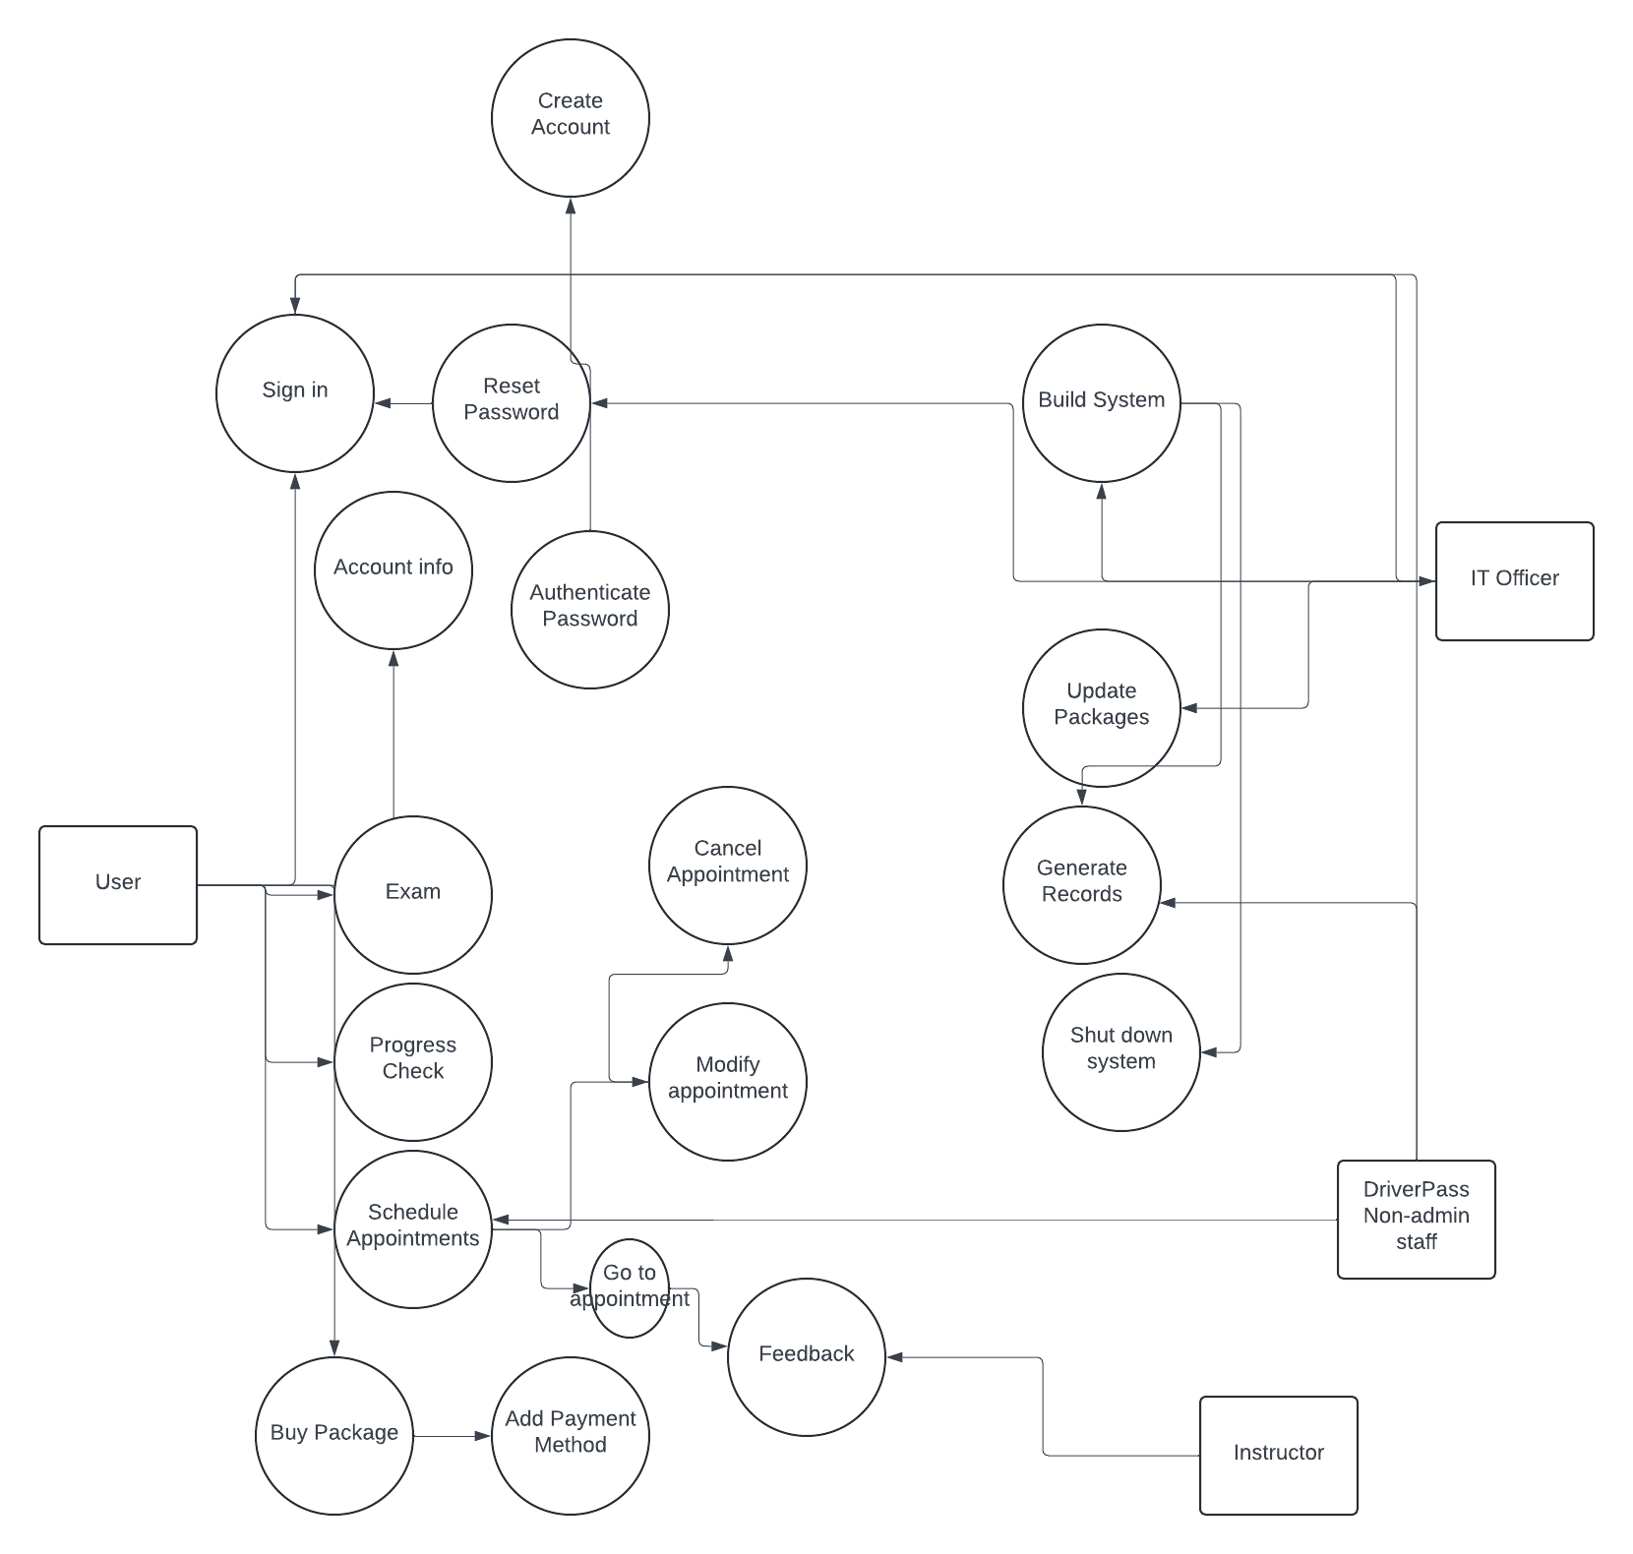

### UML Activity Diagrams

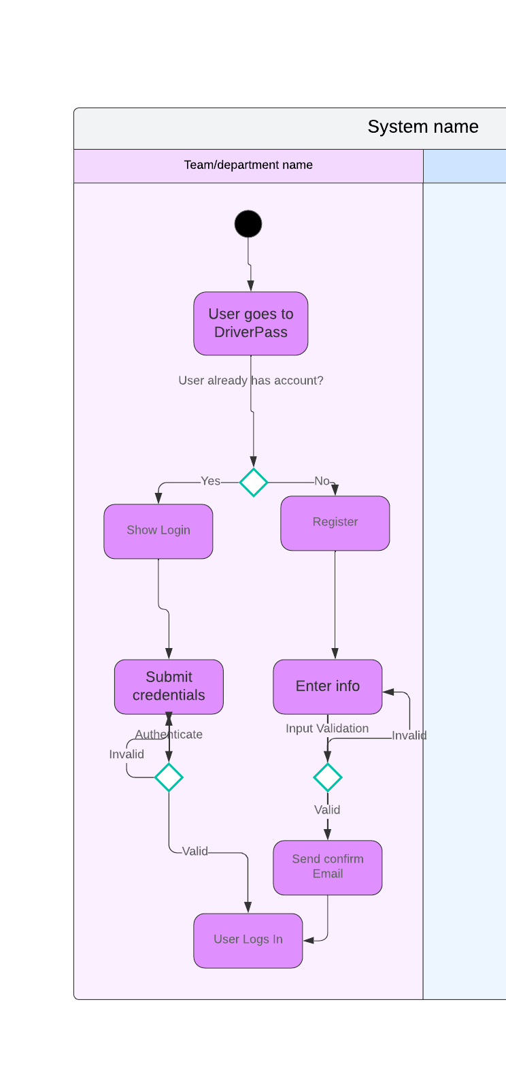

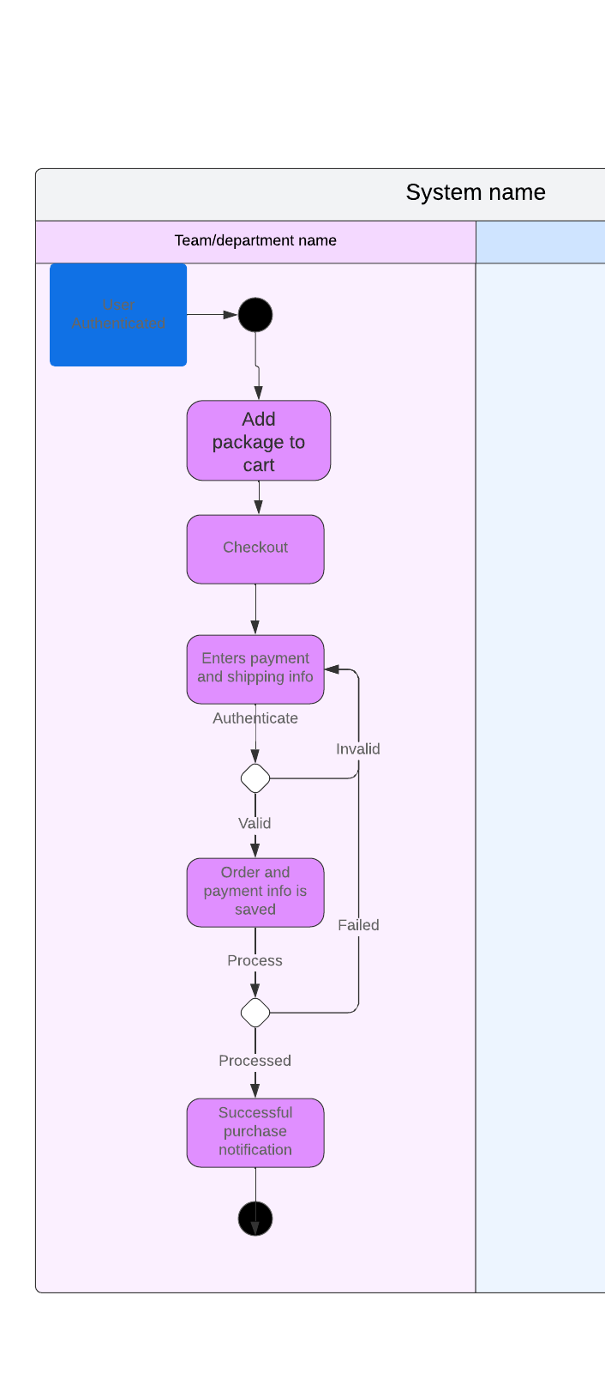

### UML Sequence Diagram

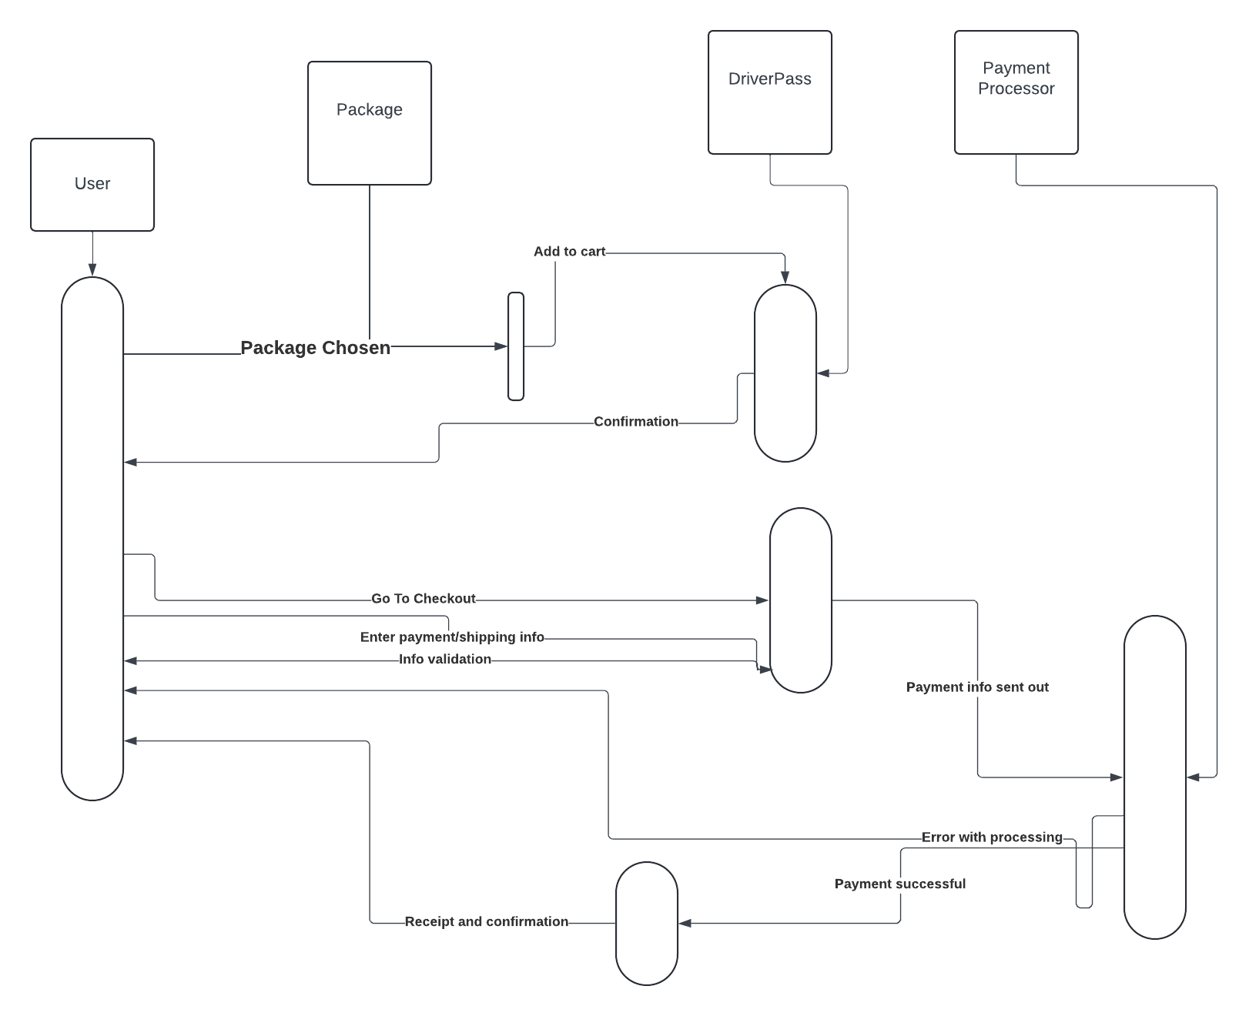

### UML Class Diagram

## Technical Requirements

Hardware:

* Dedicated Server
* Internet
* Storage for data

Software:

* Validation of payments
* Validation of user requests
* Login requests
* Password resets